CMU Computer Club
Spring '07 Movie & Retro Game Night

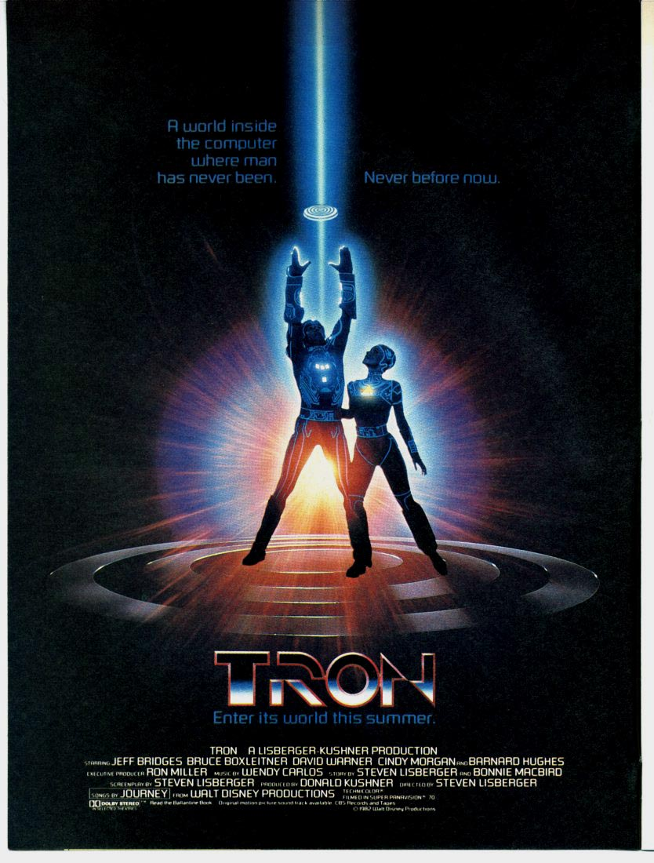

Thursday, Feb 22 · Wean 7500

Retro Games 7:00pm · Movie 8:00pm

Pizza will be ordered around 7:30

